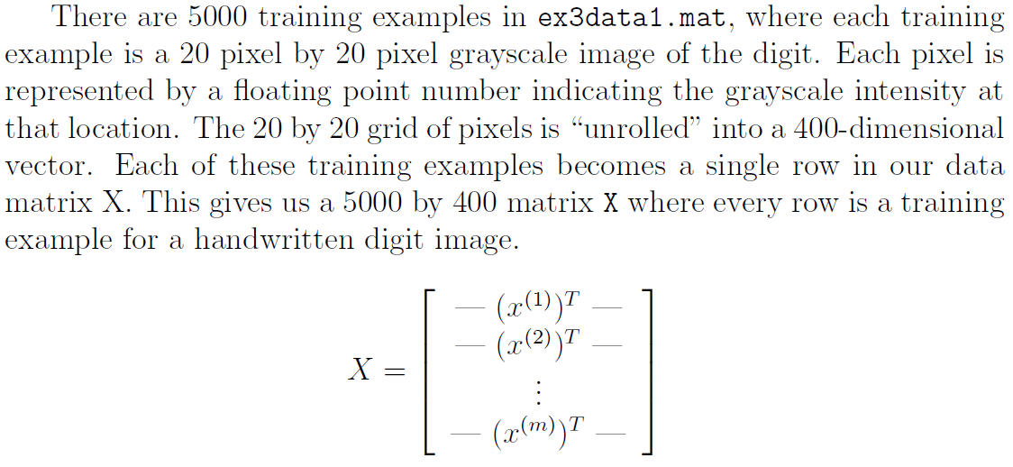

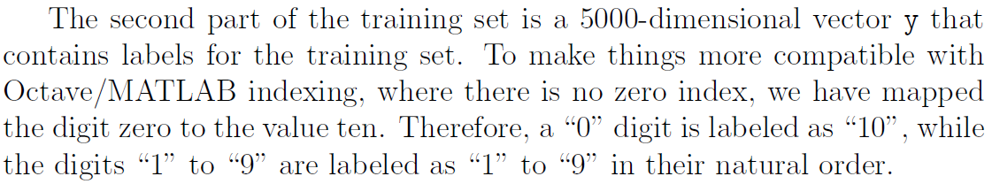

%% Machine Learning Online Class - Exercise 3 | Part 1: One-vs-all

% Instructions

% ------------

%

% This file contains code that helps you get started on the

% linear exercise. You will need to complete the following functions

% in this exericse:

%

% lrCostFunction.m (logistic regression cost function)

% oneVsAll.m

% predictOneVsAll.m

% predict.m

%

% For this exercise, you will not need to change any code in this file,

% or any other files other than those mentioned above.

%

%% Initialization

clear ; close all; clc

%% Setup the parameters you will use for this part of the exercise

input_layer_size = 400; % 20x20 Input Images of Digits

num_labels = 10; % 10 labels, from 1 to 10

% (note that we have mapped "0" to label 10)

%% =========== Part 1: Loading and Visualizing Data =============

% We start the exercise by first loading and visualizing the dataset.

% You will be working with a dataset that contains handwritten digits.

%

% Load Training Data

fprintf('Loading and Visualizing Data ...\n')

load('ex3data1.mat'); % training data stored in arrays X, y

m = size(X, 1);

% Randomly select 100 data points to display

rand_indices = randperm(m);

sel = X(rand_indices(1:100), :);

displayData(sel);

fprintf('Program paused. Press enter to continue.\n');

pause;

%% ============ Part 2a: Vectorize Logistic Regression ============

% In this part of the exercise, you will reuse your logistic regression

% code from the last exercise. You task here is to make sure that your

% regularized logistic regression implementation is vectorized. After

% that, you will implement one-vs-all classification for the handwritten

% digit dataset.

%

% Test case for lrCostFunction

fprintf('\nTesting lrCostFunction() with regularization');

theta_t = [-2; -1; 1; 2];

X_t = [ones(5,1) reshape(1:15,5,3)/10];

y_t = ([1;0;1;0;1] >= 0.5);

lambda_t = 3;

[J grad] = lrCostFunction(theta_t, X_t, y_t, lambda_t);

fprintf('\nCost: %f\n', J);

fprintf('Expected cost: 2.534819\n');

fprintf('Gradients:\n');

fprintf(' %f \n', grad);

fprintf('Expected gradients:\n');

fprintf(' 0.146561\n -0.548558\n 0.724722\n 1.398003\n');

fprintf('Program paused. Press enter to continue.\n');

pause;

%% ============ Part 2b: One-vs-All Training ============

fprintf('\nTraining One-vs-All Logistic Regression...\n')

lambda = 0.1;

[all_theta] = oneVsAll(X, y, num_labels, lambda);

fprintf('Program paused. Press enter to continue.\n');

pause;

%% ================ Part 3: Predict for One-Vs-All ================

pred = predictOneVsAll(all_theta, X);

fprintf('\nTraining Set Accuracy: %f\n', mean(double(pred == y)) * 100);

function [h, display_array] = displayData(X, example_width)

%DISPLAYDATA Display 2D data in a nice grid

% [h, display_array] = DISPLAYDATA(X, example_width) displays 2D data

% stored in X in a nice grid. It returns the figure handle h and the

% displayed array if requested.

% Set example_width automatically if not passed in

if ~exist('example_width', 'var') || isempty(example_width)

example_width = round(sqrt(size(X, 2)));

end

% Gray Image

colormap(gray);

% Compute rows, cols

[m n] = size(X);

example_height = (n / example_width);

% Compute number of items to display

display_rows = floor(sqrt(m));

display_cols = ceil(m / display_rows);

% Between images padding

pad = 1;

% Setup blank display

display_array = - ones(pad + display_rows * (example_height + pad), ...

pad + display_cols * (example_width + pad));

% Copy each example into a patch on the display array

curr_ex = 1;

for j = 1:display_rows

for i = 1:display_cols

if curr_ex > m,

break;

end

% Copy the patch

% Get the max value of the patch

max_val = max(abs(X(curr_ex, :)));

display_array(pad + (j - 1) * (example_height + pad) + (1:example_height), ...

pad + (i - 1) * (example_width + pad) + (1:example_width)) = ...

reshape(X(curr_ex, :), example_height, example_width) / max_val;

curr_ex = curr_ex + 1;

end

if curr_ex > m,

break;

end

end

% Display Image

h = imagesc(display_array, [-1 1]);

% Do not show axis

axis image off

drawnow;

end

function [J, grad] = lrCostFunction(theta, X, y, lambda)

%LRCOSTFUNCTION Compute cost and gradient for logistic regression with

%regularization

% J = LRCOSTFUNCTION(theta, X, y, lambda) computes the cost of using

% theta as the parameter for regularized logistic regression and the

% gradient of the cost w.r.t. to the parameters.

% Initialize some useful values

m = length(y); % number of training examples

% You need to return the following variables correctly

J = 0;

grad = zeros(size(theta));

% ====================== YOUR CODE HERE ======================

% Instructions: Compute the cost of a particular choice of theta.

% You should set J to the cost.

% Compute the partial derivatives and set grad to the partial

% derivatives of the cost w.r.t. each parameter in theta

%

% Hint: The computation of the cost function and gradients can be

% efficiently vectorized. For example, consider the computation

%

% sigmoid(X * theta)

%

% Each row of the resulting matrix will contain the value of the

% prediction for that example. You can make use of this to vectorize

% the cost function and gradient computations.

%

% Hint: When computing the gradient of the regularized cost function,

% there're many possible vectorized solutions, but one solution

% looks like:

% grad = (unregularized gradient for logistic regression)

% temp = theta;

% temp(1) = 0; % because we don't add anything for j = 0

% grad = grad + YOUR_CODE_HERE (using the temp variable)

%

temp = theta;

temp (1) = 0;

J = (-y'*log(sigmoid(X*theta))-(1-y)'*log(1-sigmoid(X*theta)))/m + lambda/m/2*temp'*temp;

grad = X'*(sigmoid(X*theta)-y)/m + lambda/m*temp;

% =============================================================

grad = grad(:);

end

function [all_theta] = oneVsAll(X, y, num_labels, lambda)

%ONEVSALL trains multiple logistic regression classifiers and returns all

%the classifiers in a matrix all_theta, where the i-th row of all_theta

%corresponds to the classifier for label i

% [all_theta] = ONEVSALL(X, y, num_labels, lambda) trains num_labels

% logistic regression classifiers and returns each of these classifiers

% in a matrix all_theta, where the i-th row of all_theta corresponds

% to the classifier for label i

% Some useful variables

m = size(X, 1);

n = size(X, 2);

% You need to return the following variables correctly

all_theta = zeros(num_labels, n + 1);

% Add ones to the X data matrix

X = [ones(m, 1) X];

% ====================== YOUR CODE HERE ======================

% Instructions: You should complete the following code to train num_labels

% logistic regression classifiers with regularization

% parameter lambda.

%

% Hint: theta(:) will return a column vector.

%

% Hint: You can use y == c to obtain a vector of 1's and 0's that tell you

% whether the ground truth is true/false for this class.

%

% Note: For this assignment, we recommend using fmincg to optimize the cost

% function. It is okay to use a for-loop (for c = 1:num_labels) to

% loop over the different classes.

%

% fmincg works similarly to fminunc, but is more efficient when we

% are dealing with large number of parameters.

%

% Example Code for fmincg:

%

% % Set Initial theta

% initial_theta = zeros(n + 1, 1);

%

% % Set options for fminunc

% options = optimset('GradObj', 'on', 'MaxIter', 50);

%

% % Run fmincg to obtain the optimal theta

% % This function will return theta and the cost

% [theta] = ...

% fmincg (@(t)(lrCostFunction(t, X, (y == c), lambda)), ...

% initial_theta, options);

%

initial_theta = zeros(n + 1, 1);

for i = 1:num_labels

options = optimset('GradObj','on','MaxIter',50);

all_theta(i,:) = (fmincg(@(t)(lrCostFunction(t,X,(y ==i),lambda)),initial_theta, options))';

endfor

% =========================================================================

End

function p = predictOneVsAll(all_theta, X)

%PREDICT Predict the label for a trained one-vs-all classifier. The labels

%are in the range 1..K, where K = size(all_theta, 1).

% p = PREDICTONEVSALL(all_theta, X) will return a vector of predictions

% for each example in the matrix X. Note that X contains the examples in

% rows. all_theta is a matrix where the i-th row is a trained logistic

% regression theta vector for the i-th class. You should set p to a vector

% of values from 1..K (e.g., p = [1; 3; 1; 2] predicts classes 1, 3, 1, 2

% for 4 examples)

m = size(X, 1);

num_labels = size(all_theta, 1);

% You need to return the following variables correctly

p = zeros(size(X, 1), 1);

% Add ones to the X data matrix

X = [ones(m, 1) X];

% ====================== YOUR CODE HERE ======================

% Instructions: Complete the following code to make predictions using

% your learned logistic regression parameters (one-vs-all).

% You should set p to a vector of predictions (from 1 to

% num_labels).

%

% Hint: This code can be done all vectorized using the max function.

% In particular, the max function can also return the index of the

% max element, for more information see 'help max'. If your examples

% are in rows, then, you can use max(A, [], 2) to obtain the max

% for each row.

%

[a,p] = max(sigmoid(X*all_theta'),[],2);

% =========================================================================

End

%% Machine Learning Online Class - Exercise 3 | Part 2: Neural Networks

% Instructions

% ------------

%

% This file contains code that helps you get started on the

% linear exercise. You will need to complete the following functions

% in this exericse:

%

% lrCostFunction.m (logistic regression cost function)

% oneVsAll.m

% predictOneVsAll.m

% predict.m

%

% For this exercise, you will not need to change any code in this file,

% or any other files other than those mentioned above.

%

%% Initialization

clear ; close all; clc

%% Setup the parameters you will use for this exercise

input_layer_size = 400; % 20x20 Input Images of Digits

hidden_layer_size = 25; % 25 hidden units

num_labels = 10; % 10 labels, from 1 to 10

% (note that we have mapped "0" to label 10)

%% =========== Part 1: Loading and Visualizing Data =============

% We start the exercise by first loading and visualizing the dataset.

% You will be working with a dataset that contains handwritten digits.

%

% Load Training Data

fprintf('Loading and Visualizing Data ...\n')

load('ex3data1.mat');

m = size(X, 1);

% Randomly select 100 data points to display

sel = randperm(size(X, 1));

sel = sel(1:100);

displayData(X(sel, :));

fprintf('Program paused. Press enter to continue.\n');

pause;

%% ================ Part 2: Loading Pameters ================

% In this part of the exercise, we load some pre-initialized

% neural network parameters.

fprintf('\nLoading Saved Neural Network Parameters ...\n')

% Load the weights into variables Theta1 and Theta2

load('ex3weights.mat');

%% ================= Part 3: Implement Predict =================

% After training the neural network, we would like to use it to predict

% the labels. You will now implement the "predict" function to use the

% neural network to predict the labels of the training set. This lets

% you compute the training set accuracy.

pred = predict(Theta1, Theta2, X);

fprintf('\nTraining Set Accuracy: %f\n', mean(double(pred == y)) * 100);

fprintf('Program paused. Press enter to continue.\n');

pause;

% To give you an idea of the network's output, you can also run

% through the examples one at the a time to see what it is predicting.

% Randomly permute examples

rp = randperm(m);

for i = 1:m

% Display

fprintf('\nDisplaying Example Image\n');

displayData(X(rp(i), :));

pred = predict(Theta1, Theta2, X(rp(i),:));

fprintf('\nNeural Network Prediction: %d (digit %d)\n', pred, mod(pred, 10));

% Pause with quit option

s = input('Paused - press enter to continue, q to exit:','s');

if s == 'q'

break

end

end

function p = predict(Theta1, Theta2, X)

%PREDICT Predict the label of an input given a trained neural network

% p = PREDICT(Theta1, Theta2, X) outputs the predicted label of X given the

% trained weights of a neural network (Theta1, Theta2)

% Useful values

m = size(X, 1);

num_labels = size(Theta2, 1);

% You need to return the following variables correctly

p = zeros(size(X, 1), 1);

% ====================== YOUR CODE HERE ======================

% Instructions: Complete the following code to make predictions using

% your learned neural network. You should set p to a

% vector containing labels between 1 to num_labels.

%

% Hint: The max function might come in useful. In particular, the max

% function can also return the index of the max element, for more

% information see 'help max'. If your examples are in rows, then, you

% can use max(A, [], 2) to obtain the max for each row.

%

X_ = [ones(m,1) X];

[a,p] = max(sigmoid([ones(m,1) sigmoid(X_*Theta1')]*Theta2'),[],2);

% =========================================================================

end